University Signage Guidelines
July, 2012

Please refer to the University’s permanent signage guidelines that can be accessed at:
http://campus.udayton.edu/~facman/planning/signage

Temporary Exterior Signage

Temporary exterior signage is employed by various groups on campus throughout the year as informational, directional, and special event signage. Please note the following requirements for such signage:

Any signs that are staked into the ground, whether utilizing metal or wood stakes are not permitted:

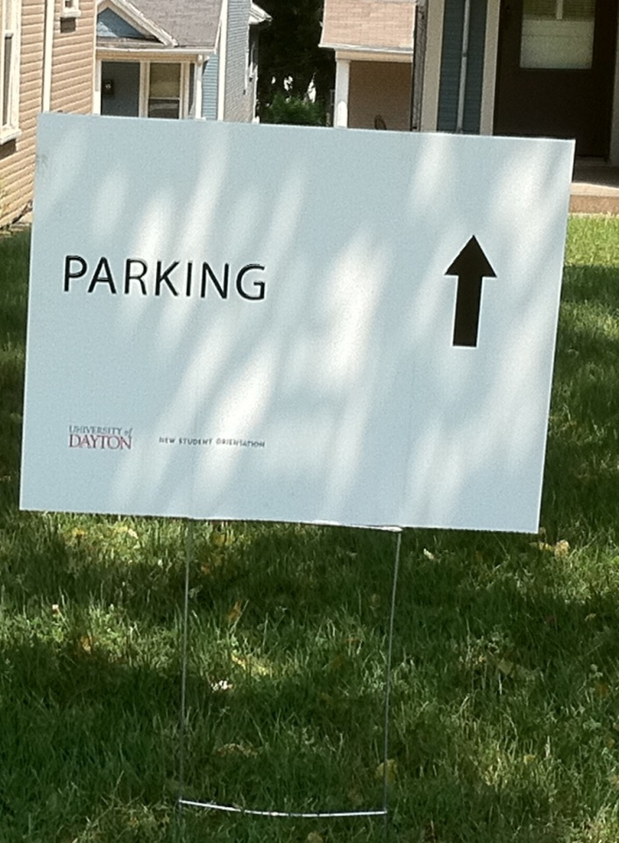

Installation of these types of signs damage the landscaping, the underground irrigation, and blow over and become unsightly.

Signs that are on weighted bases or ‘easel’ type are permitted.

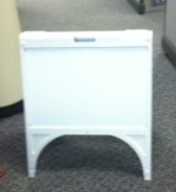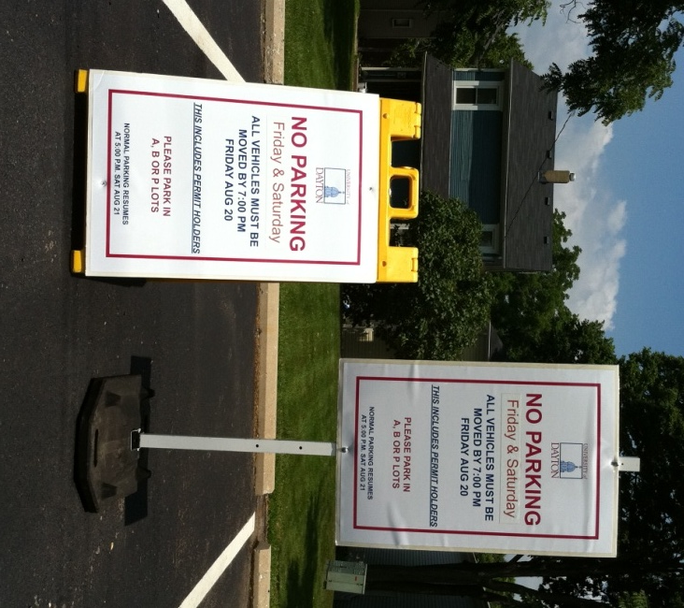

Reserving signs for your event:

Please go to:
http://campus.udayton.edu/~facman/workrequests/

and click the link for:
“Faculty and Staff (Campus Buildings)
Submit New Academic Request

Then please complete the work order information including the location of your event, timeframe, contact name and phone number, account number, and how many sign holders you will require.

FM will contact you to confirm your request, and at that time information will be provided on the size of the sign inserts for the holders that are reserved for your function. Please note that your function is responsible for providing the inserts that must be professional printed, hand lettered inserts are not acceptable. You will also be responsible for inserting the professionally printed inserts into the sign holder frame. An account number must be provided in the event that sign holders are damaged or not returned, at which time the account number will be charged.

FM Grounds will deliver all of the requested sign holders to your event site. You will be responsible for any necessary distribution of the signs around campus. You will need to gather the sign holders and return to the drop-off site after the event. FM Grounds will arrange to pick up all of the sign holders from the same, central location once your event is concluded. PLEASE NOTE: Drop-off and pick-up of the sign holders by FM Grounds must be within the following hours: M-F 7:00 AM – 3:30 PM or Sat/Sun 7:00 AM – 2:30 PM.

Temporary Interior Signage

Please note that temporary interior event or directional signage is not permitted to be taped on walls, doors, door frames, glass, or any other object.

If you require long-term directional signage, please submit a work order at:
http://campus.udayton.edu/~facman/workrequests/

and click the link for:
“Faculty and Staff (Campus Buildings)
Submit New Academic Request

For 1700 South Patterson Building only:
The University stocks a limited number of movable interior sign holders for use for special events at 1700 South Patterson Building.

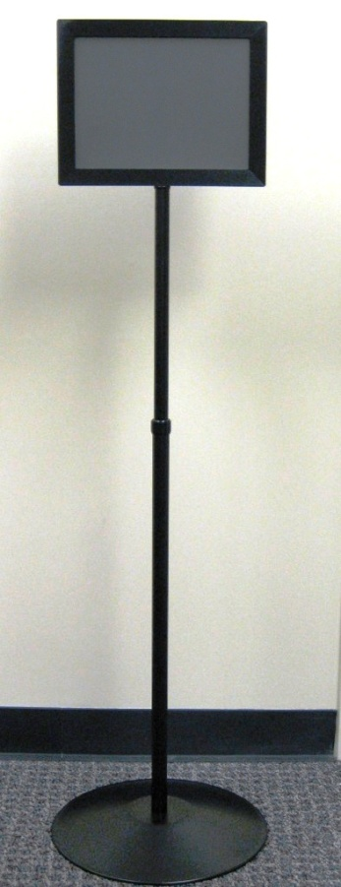

To reserve interior sign holders for special events at 1700, please submit a work order:
http://campus.udayton.edu/~facman/workrequests/

and click the link for:
“Faculty and Staff (Campus Buildings)
Submit New Academic Request

Then please complete the work order information including the location of your event, timeframe, contact name and phone number, account number, and how many sign holders you will require.

FM will contact you to confirm your request, and at that time information will be provided on the size of the sign inserts for the holders that are reserved for your function. Please note that your function is responsible for providing the inserts that must be professional printed, hand lettered inserts are not acceptable. You will also be responsible for inserting the professionally printed inserts into the sign holder frame. An account number must be provided in the event that sign holders are damaged or not returned, at which time the account number will be charged.

